

**SOFTWARE ENGINEERING**

**USE CASE DIAGRAMS**

**Group members:**

**NOOR-UL-HUDA F2023266853**

**NIMRA MAQBOOL F2023266852**

**KHAZAIMA TAJAMMAL F2023266890**

**USE CASES**

**CASE NUMBER 1:**

“Facial Recognition for Identification”

**Description:** Identify missing individuals based on their facial features, even with age-related or appearance changes.

**Involves:**

**AI algorithm:** Deep Neural Networks (e.g., ResNet)

**Cameras:** High-resolution surveillance systems

**Software:** OpenCV, TensorFlow

**Database:** Centralized image storage

**Shapes in Diagram:**

**Actor:** User

**Use Case:** Circle labeled "Facial Recognition"

**System:** Rectangle labeled "AI Recognition Engine"

**USE CASE DIAGRAM:**

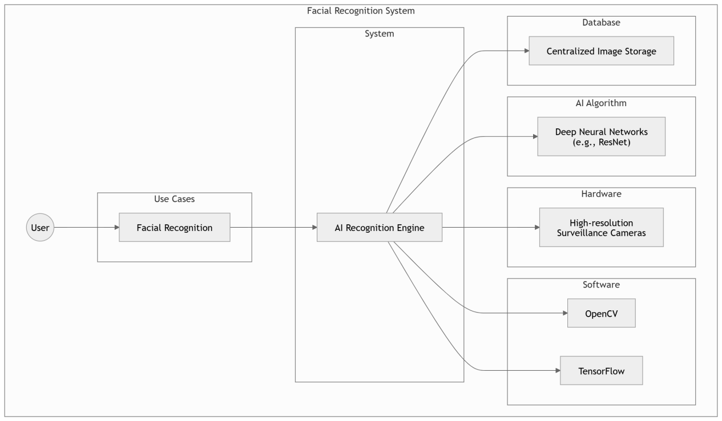

**CASE NUMBER 2:**

“Attribute-Based Search”

**Description:** Search for individuals using descriptive traits like clothing or accessories.

**Involves:**

**AI algorithm:** Object detection and feature matching

**GUI:** Input form for descriptions (e.g., "blue shirt, red bag")

**Database:** Metadata storage for images/videos

**Shapes in Diagram:**

**Actor:** User

**Use Case:** Circle labeled "Attribute-Based Search"

**System:** Rectangle labeled "Feature Matching Engine"

**USE CASE DIAGRAM:**

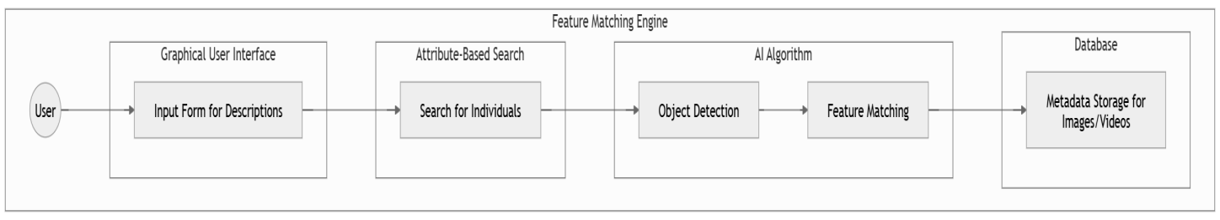

**CASE NUMBER 3:**

“Multi-Camera Re-Identification”

**Description:** Track individuals across multiple camera feeds and locations.

**Involves:**

**AI algorithm:** Person re-identification

**Cameras:** Network of synced surveillance systems

**Software:** Real-time data processing

**Shapes in Diagram:**

**Actor:** Admin/User

**Use Case:** Circle labeled "Multi-Camera Tracking"

**System:** Rectangle labeled "Camera Network"

**USE CASE DIAGRAM:**

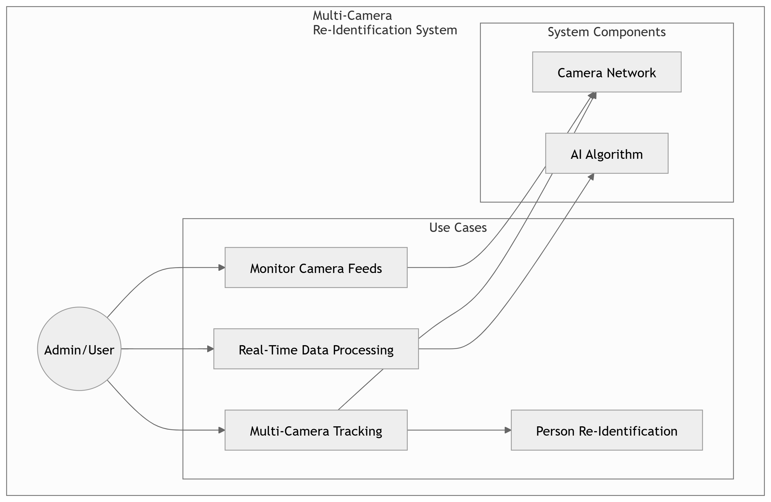

**CASE NUMBER 4:**

“Real-Time Alerts”

**Description:** Notify users when the system identifies or tracks a missing person.

**Involves:**

**Software:** Push notification services

**Communication:** Email, SMS, or app notifications

**Hardware:** Mobile devices

**Shapes in Diagram:**

**Actor:** User

**Use Case:** Circle labeled "Real-Time Alerts"

**System:** Rectangle labeled "Notification System"

**USE CASE DIAGRAM:**

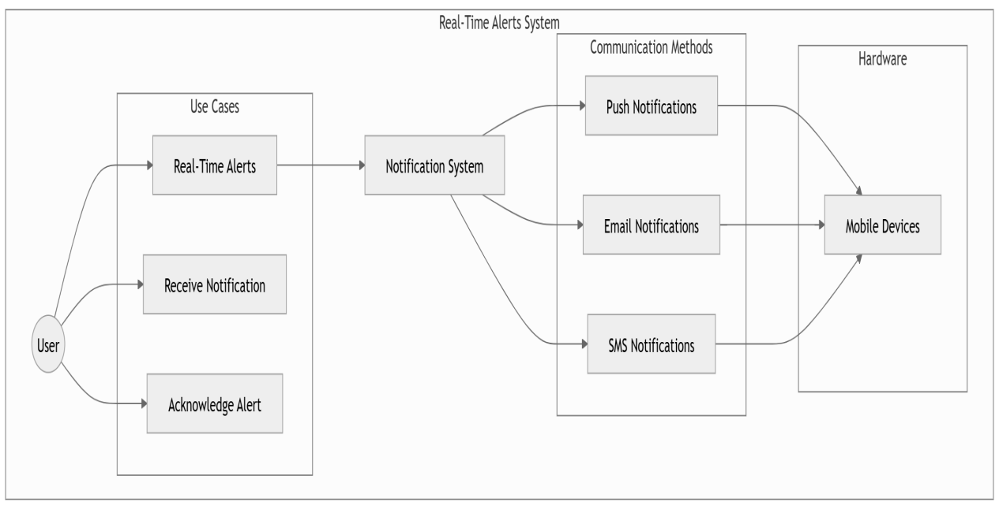

**CASE NUMBER 5:**

“RFID and GPS Tracking”

**Description:** Use wearable RFID or GPS devices to track vulnerable individuals.

**Involves:**

**Hardware:** Wearable trackers

**Software:** GPS mapping and integration

**Network:** Cloud-based location services

**Shapes in Diagram:**

**Actor:** User

**Use Case:** Circle labeled "RFID/GPS Monitoring"

**System:** Rectangle labeled "Location Tracker"

**USE CASE DIAGRAM:**

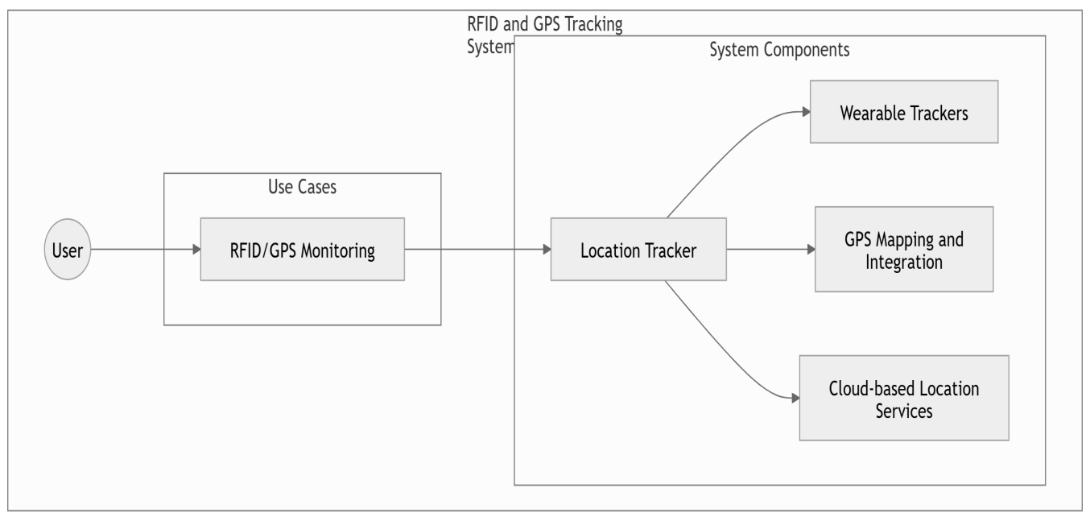

**CASE NUMBER 6:**

“Missing Person Database Integration”

**Description:** Leverage public or government datasets for cross-referencing information.

**Involves:**

**Databases:** Aadhaar (India), police records

**API:** Integration services

**Software:** Query systems

**Shapes in Diagram:**

**Actor:** Admin

**Use Case:** Circle labeled "Database Integration"

**System:** Rectangle labeled "External Data Source"

**USE CASE DIAGRAM:**

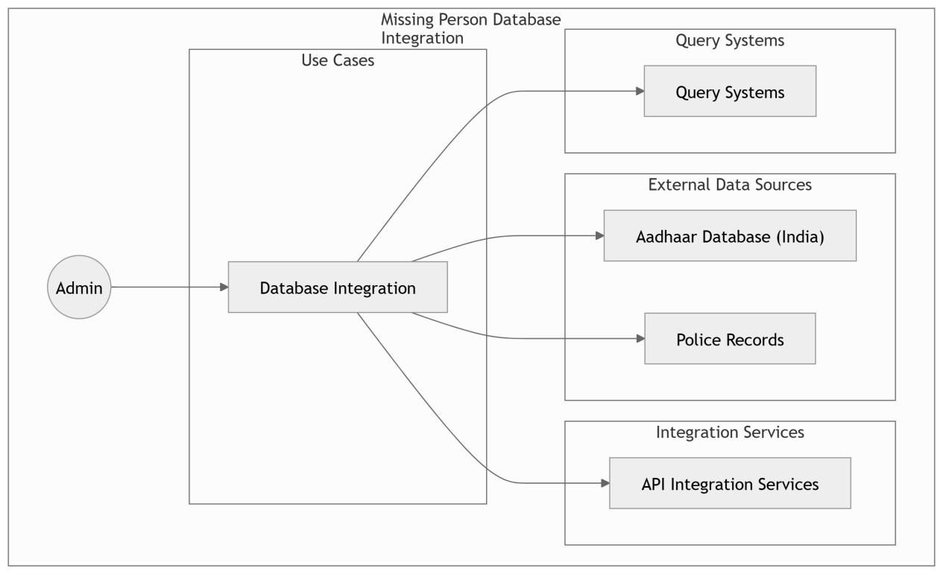

**CASE NUMBER 7:**

“Heatmap and Movement Analytics”

**Description:** Generate visual heatmaps to analyze crowd density and movement trends.

**Involves:**

**AI algorithm:** Data analytics and visualization

**Software:** Reporting tools (e.g., Tableau, Python Matplotlib)

**Cameras:** Surveillance data input

Shapes in Diagram:

**Actor:** Analyst

**Use Case:** Circle labeled "Generate Heatmap"

**System:** Rectangle labeled "Analytics Engine"

**USE CASE DIAGRAM:**

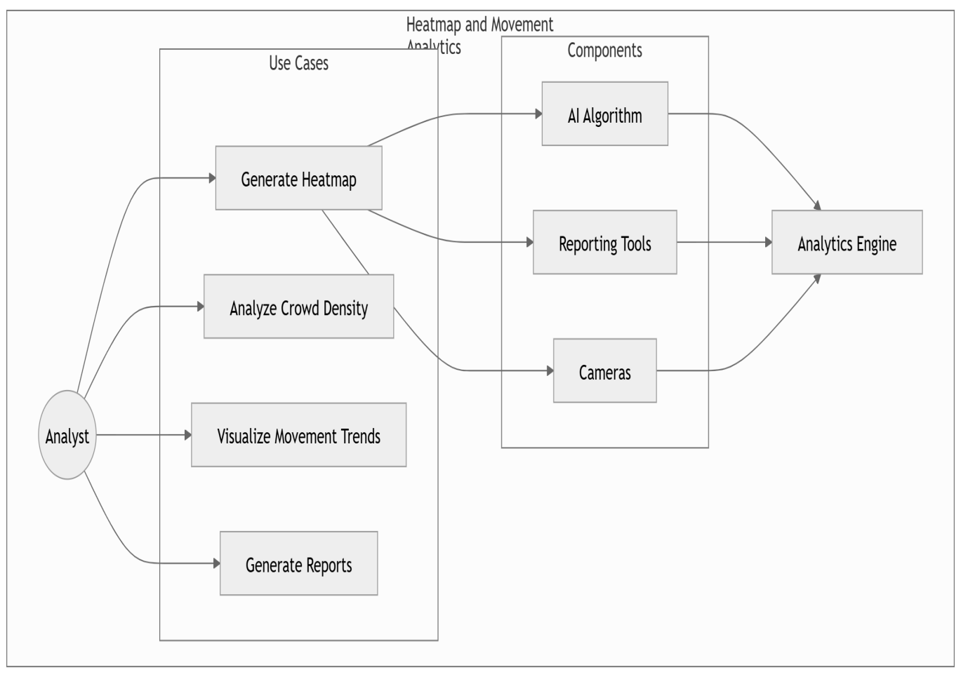

**CASE NUMBER 8:**

“Cross-Age Recognition”

**Description:** Identify individuals whose appearance has changed significantly over time.

**Involves:**

**AI algorithm:** Age-progression models

**Software:** AWS Rekognition, TensorFlow

**Database:** Historical facial data

**Shapes in Diagram:**

**Actor:** User

**Use Case:** Circle labeled "Cross-Age Recognition"

**System:** Rectangle labeled "Facial Analysis Engine"

**USE CASE DIAGRAM:**

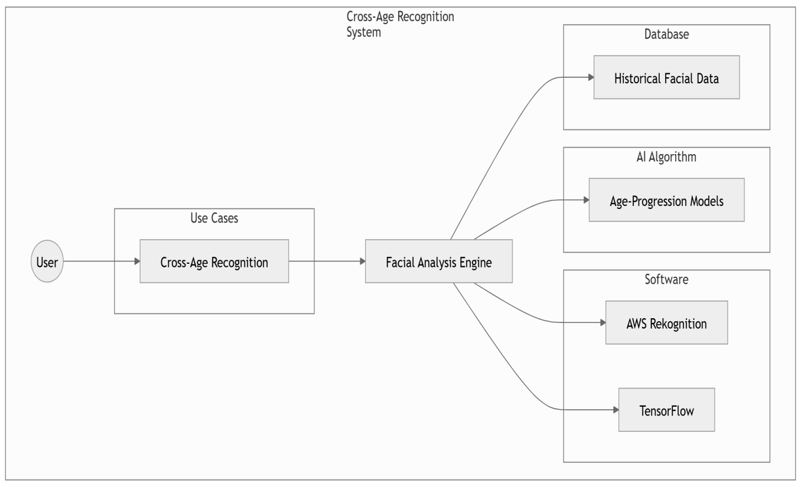

**CASE NUMBER 9:**

“Reporting and Performance Metrics”

**Description:** Provide detailed analytics on system performance, matches, and search success rates.

**Involves:**

**Software:** Analytics and reporting tools

**Databases:** Historical performance logs

**GUI:** Dashboards for users

**Shapes in Diagram:**

**Actor:** Admin/Analyst

**Use Case:** Circle labeled "Generate Reports"

**System:** Rectangle labeled "Reporting Tool"

**USE CASE DIAGRAM:**

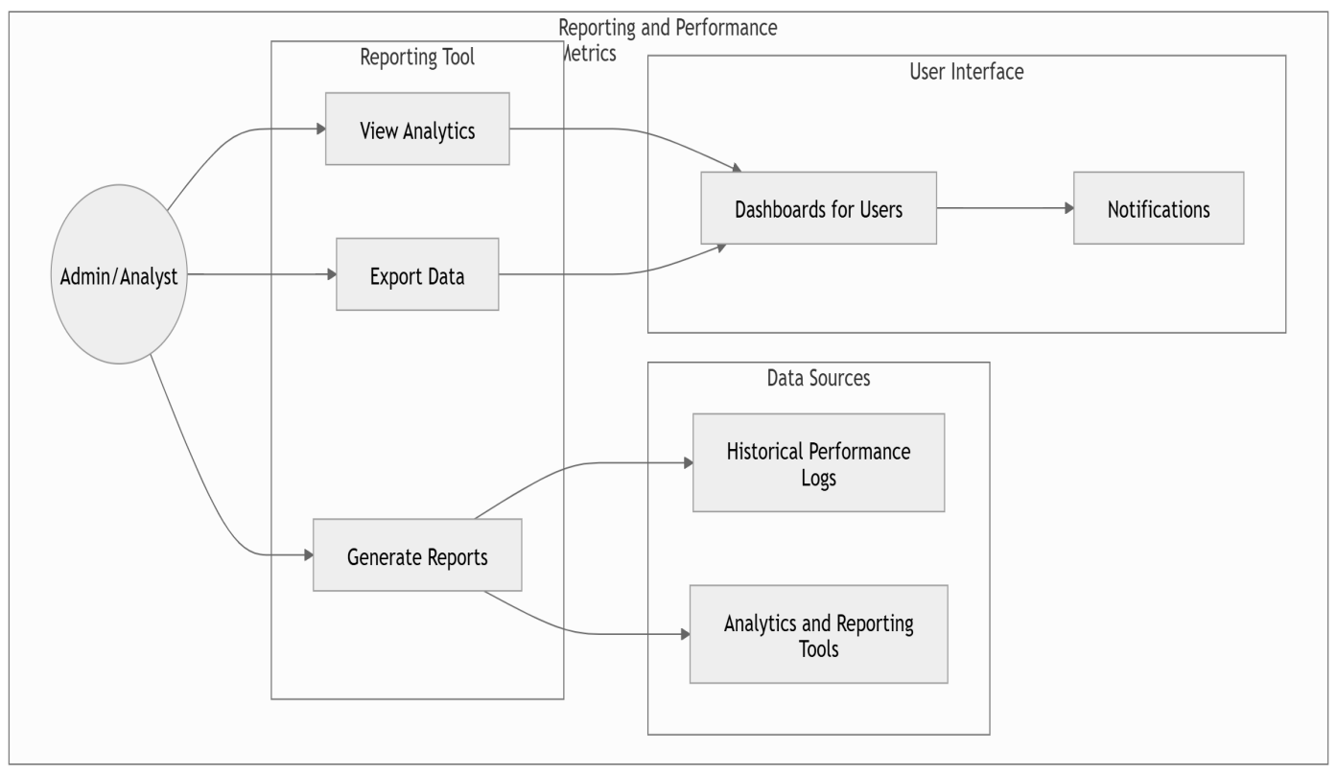

**CASE NUMBER 10:**

“Emergency Hotlines and User Support”

**Description:** Allow users to report sightings or provide information through the system.

**Involves:**

**Software:** Hotline integration with VoIP services

**GUI:** Support chat interface

**Networking:** Real-time communication systems

**Shapes in Diagram:**

**Actor:** User

**Use Case:** Circle labeled "Emergency Support"

**System:** Rectangle labeled "Hotline System"

**USE CASE DIAGRAM:**

